UP2237432

Data Management

Coursework 2

Contents

1. Introduction
2. Database code
3. Database queries
4. Reflection process
5. References

1. Screenshots to show what is in the database and how it is made are as follows.

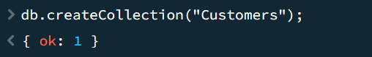

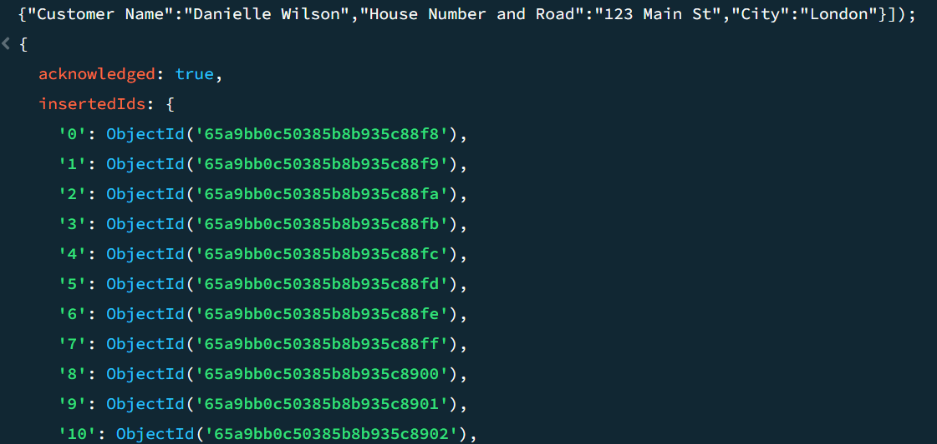

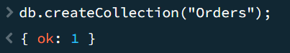

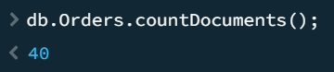

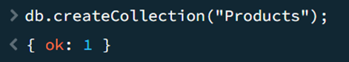

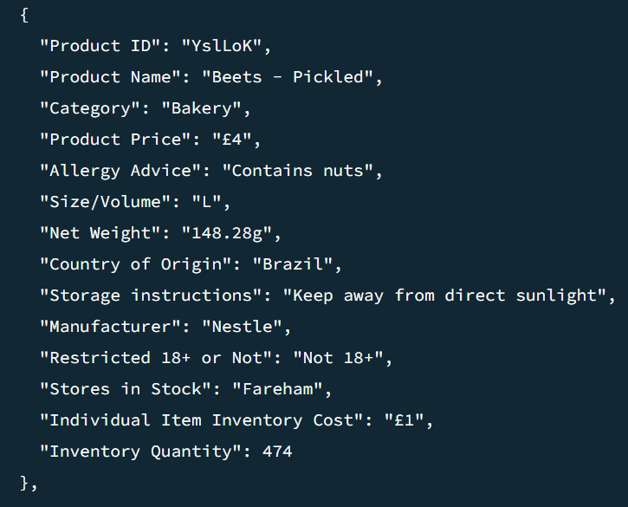

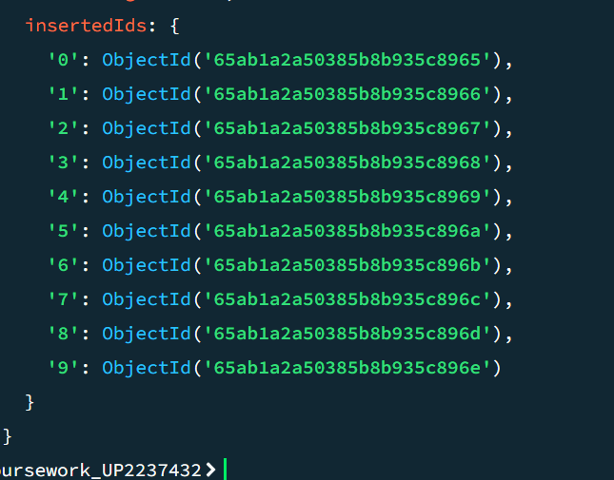

1. Code for 3 queries related to the business is below.

* To find what 18 plus item is most stocked in Chichester and Havant

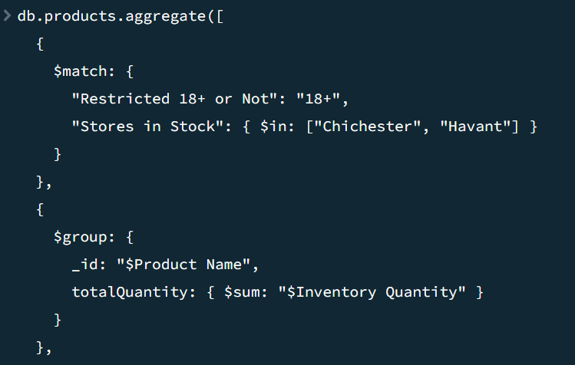

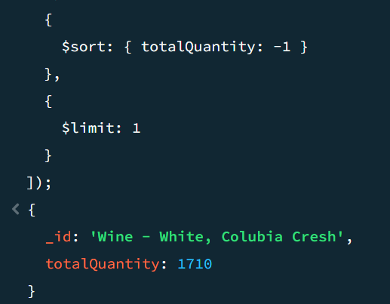

* To find the product that comes from Australia that is most in stock.

* The biggest order on the database.

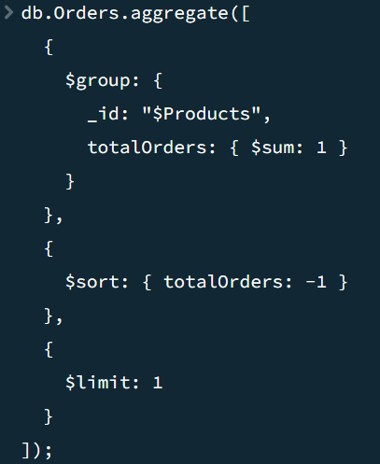

1. The three queries were planned first to make sure it was possible to access data for them from the database. It involved revising content from the lectures and doing some research online and to make sure the queries were creatable. Then it was important to create collections, for orders, products, stores and customers to make enough content for the queries and to make the database look realistic. Once the three data queries were made, then it was possible to make the database.

The queries were picked to help a business analyst to gain some idea into how the business structure is, with an understanding of what the business prioritises when it comes to ordering products from different parts of the world, what the business has prepared to deal with demand for 18 plus items in 2 stores and who could be the most loyal customer.

As the queries needed location, 18+ or not, inventory quantity, record of orders and more it was important to plan out the schema. These fields and others were added to make the database look realistic. The database was created using Mockaroo data, some editing to it and then the use of insertMany() or insertOne() functions. It took time to create because of Mockaroo’s data often being poor and so needing to replace content, but with MongoDB being case sensitive and requiring “” in the right places it was so important to make sure everything is correct.

After creating the database when typing up the queries, I found in the end I had an error with the ‘_id’ under question 3. I had originally put just ‘Products’ and it turned out to come up with 0 in Total Orders, so I had to research again and found I need to ensure that I always add $ in front of a data category name with the group function as it is a vital part of the aggregation process(OpenAi, 2022).

References

(For joints content not taught in lectures)

MongoDB Aggregation Pipeline: $match Operator

URL: https://www.mongodb.com/docs/manual/reference/operator/aggregation/match/

MongoDB. (n.d.). Aggregation Pipeline: $match Operator. Retrieved from https://www.mongodb.com/docs/manual/reference/operator/aggregation/match/

MongoDB Aggregation Pipeline: $group Operator

URL: https://www.mongodb.com/docs/manual/reference/operator/aggregation/group/

MongoDB. (n.d.). Aggregation Pipeline: $group Operator. Retrieved from https://www.mongodb.com/docs/manual/reference/operator/aggregation/group/

MongoDB Query Operator: $in

URL: https://www.mongodb.com/docs/manual/reference/operator/query/in/

MongoDB. (n.d.). Query Operator: $in. Retrieved from <https://www.mongodb.com/docs/manual/reference/operator/query/in/>

OpenAI. (2022, January 20). AI Chat Interaction on [When do I need a $ sign on mongosh]. ChatGPT. https://chat.openai.com/